Apol Medrano
Heritage University 10-06-23
Mathematics and Computer Science Dept. Due: 10-22-23

C++
Homework 6
(files, arrays, vectors)

1. Write a program that will compute the average word length (average number of characters per word) for a file that contains some text. A word is defined to be any string of symbols that is preceded and followed by one of the following at each end: a blank, a comma, a period, the beginning of a line, or the end of a line. Your program should define a function that is called with the input-file stream as an argument. This function should also work with the stream cin as the input stream, although the function will not be called with cin as an argument in this program. Ch.6,P371,#4

//HW6 Q1 Apol Medrano
//average word length of string from text
#include <iostream>
#include <fstream>
#include <string>
#include <cctype>
using namespace std;

void CopyCountPrint (ifstream& inStream, string line);
//gets line from file, counts words,
//calculates average word length, prints output
void CopyCountPrint(istream& cin, string line);
//gets line from cin, counts words,
//calculates average word length, prints output

int main()
{
ifstream inStream;
string line;
CopyCountPrint(inStream,line);
return 0;
}
void CopyCountPrint (ifstream& inStream, string line)
{
inStream.open("Q1Text.txt");
string result("");
int wordCount = 0;
double sumOFLength = 0;
while(getline(inStream, line))
{
string word("");
for (int i=0; i<line.length();i++)
{
if (isalpha(line.at(i)))
word += line.at(i);

if (!isalpha(line.at(i)))
{
if (word.length()>0)
{
wordCount++;
sumOFLength += word.length();
}

result += word;
result += line.at(i);
word = "";
}
}
}
cout << "The string of text:\n";
cout << "\"" << result << "\"" << endl;
cout << "\nThe text contains " << wordCount << " words "
<< "with the average length of words being " << (sumOFLength/wordCount) << ".\n";
inStream.close();
}
void CopyCountPrint(istream& cin, string line)
{
string result("");
int wordCount = 0;
double sumOFLength = 0;
while(getline(cin, line))
{
string word("");
for (int i=0; i<line.length();i++)
{
if (isalpha(line.at(i)))
word += line.at(i);

if (!isalpha(line.at(i)))
{
if (word.length()>0)
{
wordCount++;
sumOFLength += word.length();
}

result += word;
result += line.at(i);
word = "";
}
}
}
cout << "The string of text:\n";
cout << "\"" << result << "\"" << endl;
cout << "The text contains " << wordCount << " words "
<< "with the average length of words being " << (sumOFLength/wordCount) << ".\n";
}

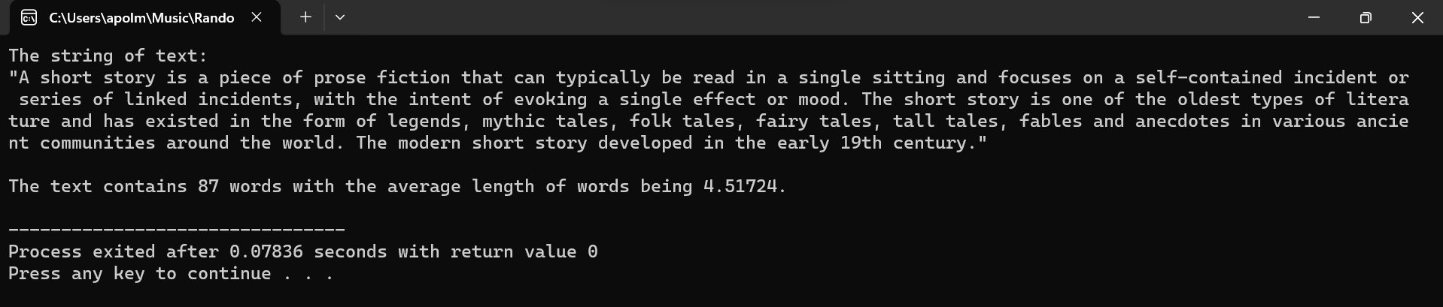
QUESTION 1 OUTPUT:

FILE USED IN Q1 “Q1TEXT”:
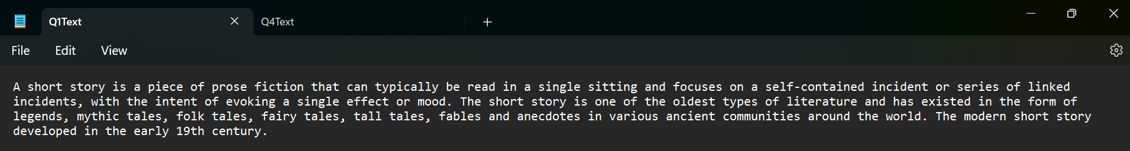

2. Create a list by using vectors. After the insertion of 10 integer numbers keep other 5 free positions. Finally increase all the items of the vector by 100.
Hint: Use functions

//HW6 Q2 Apol Medrano
//list with vectors, enter 10 values, keep 5 open, add 100 to values
#include <iostream>
#include <vector>
using namespace std;

void FillVector (vector<int>& vect);
//takes vector
//returns vector filled with user inputed values
void addHundred (vector<int> vect);
//takes vector
//adds 100 to all values and prints to screen

int main()
{ //intializes vector size to 15
vector<int> vect(15); //sets values to zero
FillVector(vect);
cout << "The numbers are now:\n";
addHundred(vect);
return 0;
}
void FillVector (vector<int>& vect)
{
int next;

cout << "Enter a list of 10 positive numbers.\n"
<< "Place a negative number to end list before 10.\n";
for (unsigned int index = 0; index < 10; index++)
{ //only fills vector to vect[9]
cin >> next;
if (next < 0)
break; //option to let user end list
//if they enter a negative number
vect[index] = next;
}
}
void addHundred (vector<int> vect)
{
for (unsigned int index = 0; index <vect.size( ); index++)
{
vect[index] += 100; //adds 100 to all values within vect
cout << vect[index] << " ";
} //prints the vector value to screen
cout << endl;
}

QUESTION 2 OUTPUT:
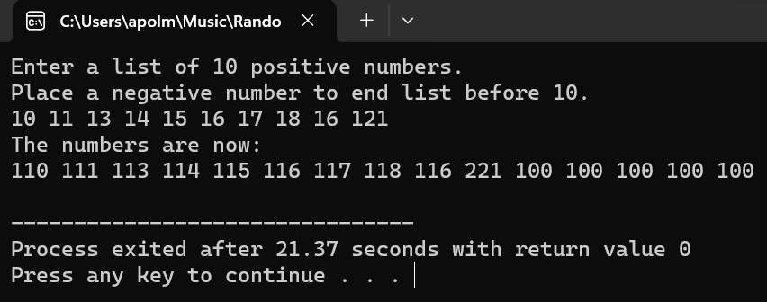

3. Write a program that reads in a line of text and replaces all four-letter
words with the word "love". For example, the input string
I hate you, you dodo!
should produce the output
I love you, you love!
Of course, the output will not always make sense. For example, the input
string
John will run home.
should produce the output
Love love run love.
If the four-letter word starts with a capital letter, it should be replaced by
"Love", not by "love". You need not ch eck capitalization, except for the
first letter of a word. A word is any string consisting of the letters of the
alphabet and delimited at each end by a blank, the end of the line, or any
other character that is not a letter. Your program should repeat this action
until the user says to quit. Ch.8, p.500,#4

//HW6 Q3 Apol Medrano
//replaces 4 lettered words in string to "love"
#include <iostream>
#include <string>
#include <cctype>
using namespace std;
int main ()
{
char ans;
string line;
cout << "Enter anything you'd like:\n";
getline(cin, line);
do
{
string result("");
string word("");
line += " ";
for (int i=0;i<line.length();i++)
{
char letter = line.at(i);
if (isalpha(letter))
word += letter;
if (!isalpha(letter))
{
if (word.length() == 4)
{
if (isupper(word[0]))
word = "Love";
else
word = "love";
}
result += word;
result += letter;
word = "";
}
}
cout << result << endl;
cout << "Retry? Y for yes, N for no.\n";
cin >> ans;
if ((ans == 'Y')||(ans == 'y'))
{
cout << "Enter anything you'd like:\n";
cin.ignore();
getline(cin, line);
}
} while ((ans == 'Y')||(ans == 'y'));
return 0;
}

QUESTION 3 OUTPUT:
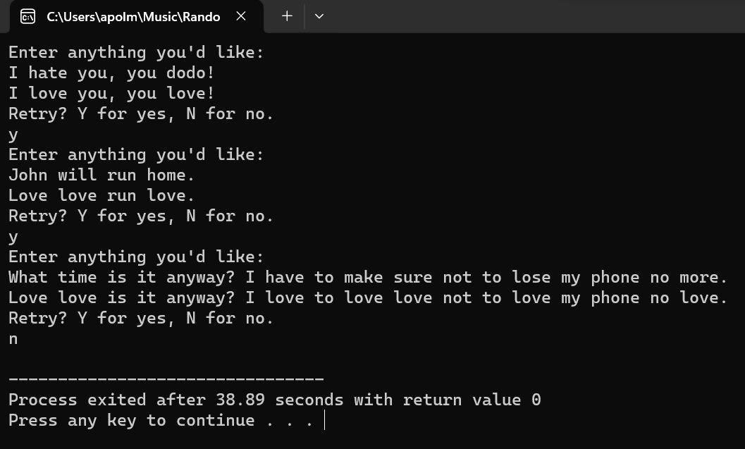

4. Write a program that will read a line of text and output a list of all the letters
that occur in the text together with the number of times each letter
occurs in the line. End the line with a period that serves as a sentinel
value. The letters should be listed in the following order: the most frequently
occurring letter, the next most frequently occurring letter, and
so forth. Use two arrays, one to hold integers and one to hold letters.
You may assume that the input uses all lowercase letters. For example,
the input
do be do bo.
should produce output similar to the following:
Letter Number of Occurrences
o 3
d 2
b 2
e 1
Your program will need to sort the arrays according to the values in the
integer array. This will require that you modify the function sort given
in Display 7.12. You cannot use sort to solve this problem without
changing the function. If this is a class assignment, ask your instructor if
input/output should be done with the keyboard and screen or if it
should be done with files. If it is to be done with files, ask your
instructor for instructions on file names. Ch.7, p445,#8

//HW6 Q4 Apol Medrano
//sort letters of string from file
//print number of letter occurence
#include <iostream>
#include <string>
#include <cctype>
#include <fstream>
using namespace std;
void SortLetters (string& result);
//takes in string and sorts them alphabetic order
//using bubblesort method
void NumberOfLetters (const string result);
//counts the number of letters, saves letter and amount of letter to array
void PrintArray (char Letter[], int LetterCount[], int LetterLocation);
//prints a letter and the amount of times it shows up in the text
void SortArray (char Letter[], int LetterCount[], int LetterLocation);
//takes in two arrays and sorts them in descending order
int main ()
{ //opens file
ifstream InStream("Q4text.txt");
string line, wholeText, result;
cout << "Text From File:\n";
while(!InStream.eof()) //makes sure entireity of file is read
{
getline(InStream,line);//gets text from file turns it into string
for (int index = 0; index < line.length(); index++)
{
char letter = tolower(line[index]);
if (isalpha(letter))
{
result += letter;
} //save letters to string
else
{
result += ""; //every not letter is ommitted, just need letter
}
}
cout << line << endl; //prints file to users
}
SortLetters(result);
NumberOfLetters(result);
return 0;
}
void SortLetters (string& result)
{ //sorts letters using bubble sort method
for (int i = result.length()-1; i > 0; i--)
for (int index = 0; index < i; index++)
if (result[index] > result[index+1])
{
// Swap the numbers
int temp = result[index+1];
result[index+1] = result[index];
result[index] = temp;
}
}
void NumberOfLetters(const string result)
{ //saves the letters that show up in text to an array called letter
char Letter[26]; //saves the amount of time they show up in the text
int LetterCount[26]; //to an array called LetterCount
int WordCount = 1;
int LetterLocation = 0;
for (int index = 1; index < result.length()+1; index++)
{
char letter = result[index];
if (result[index-1] == letter)//old index number must be equal to new one
{
WordCount++; //if so it causes the consecutive count to go up
}
else
{
Letter[LetterLocation] = (result[index-1]);
LetterCount[LetterLocation] = WordCount;
LetterLocation++;
WordCount = 1; //so if a streak ends, it goes back to zero
} //instead of stacking when a new streak begins
}
cout << endl;
PrintArray(Letter,LetterCount,LetterLocation);
}
void PrintArray (char Letter[], int LetterCount[], int LetterLocation)
{
SortArray (Letter,LetterCount,LetterLocation);
for (int index = 0; index < LetterLocation; index++)
{
cout << Letter[index] << " " << LetterCount[index] << endl;
} //prints the array values to screen
cout << endl;
}
void SortArray (char Letter[], int LetterCount[], int LetterLocation)
{//sorts letters using altered bubble sort method
for (int i = 0; i < LetterLocation; i++)
for (int index = 0; index < i; index++)
if (LetterCount[i] > LetterCount[index])
{
// Swap the numbers
int temp = LetterCount[i];
int temp2 = Letter[i];
LetterCount[i] = LetterCount[index];
Letter[i] = Letter[index];
LetterCount[index] = temp;
Letter[index] = temp2;
}
}

QUESTION 4 OUTPUT:
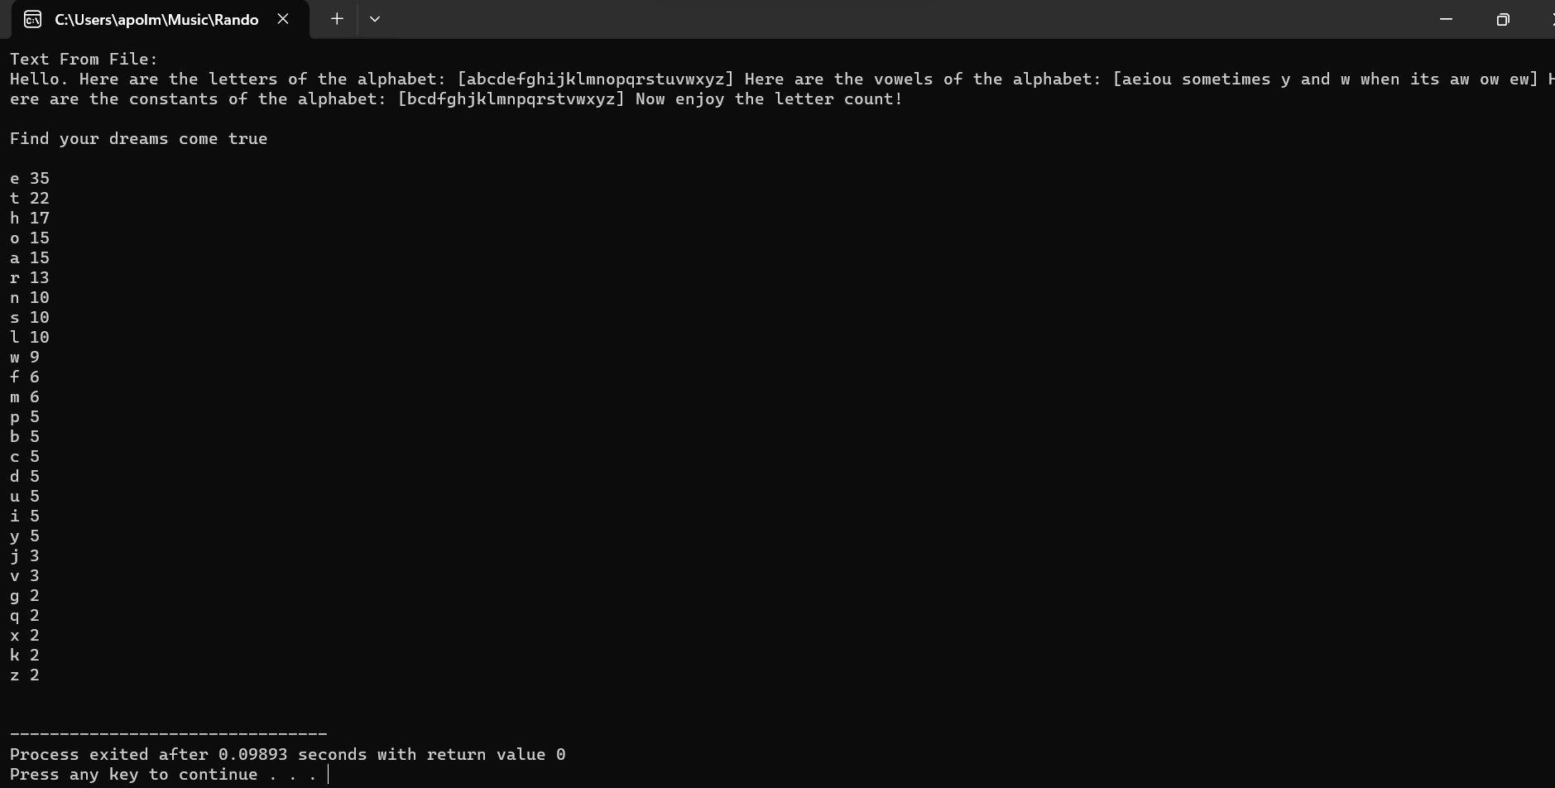

TEXT USED IN Q4:
